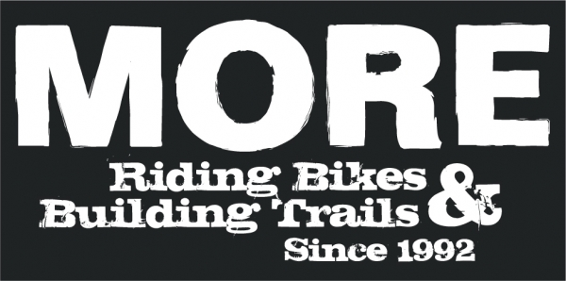

2/14/13

To our colleagues at DNR/Patapsco State Park –

I am writing today in support of Adventures for the Cure.

MORE has had a long and strong relationship with AFC. Many of AFC’s members and supporters are part of the MORE family and they play a critical role in MORE’s involvement and successes at PVSP.

AFC’s efforts towards producing the Patapsco 100 cycling event will play an important role in highlighting PVSP's world-class trail system. MORE and AFC are confident that this event will foster interest and involvement in the north side of park and will subsequently help redistribute some of the heavy use in the south end of PVSP.  Similar events like the MORE MoCo Epic® have provided direct investments in park facilities and substantial resources for the maintenance of trail systems.  We believe that this event has the potential to be asset to the stewardship of Patapsco Valley State Park.

As clearly demonstrated by the annual Sugarhill XC bike race in the Avalon area, you can count on our partners at AFC produce a quality event. MORE will be working hand in hand with AFC to not only insure a successful event, but to use the opportunity to increase awareness of sustainable trail, responsible use and promote opportunities to contribute to PVSP.

Don’t hesitate to contact me with questions or concerns.

Cordially,

Dave Ferraro

President, MORE